CSCI 5331.01 Advanced Operating Systems
Program 2- Documentation

/************************************************************************
- Programmer: Sarath Madala

- Course: CSCI 5531.01
*
- Date: October 25, 2018

- Assignment: Project #2: Implementing RMI Architecture

- Environment: Java runtime Environment

        - Files Included: Server.java, Client.java, ServerInterface.java, ServerInterfaceImplementation.java
.txt
Rs

- Purpose: Checking string palindrome, integer palindrome and pattern matching using RMI architecture
- Input: Choice to choose among three methods. Integer Palindrome takes long as input. String Palindrome takes String as input. Pattern matching takes Two strings as input

- Output: For integer and string palindrome methods it will return the given input is a palindrome or not and for pattern matching it will return the indexes of the matching pattern.

//ServerInterfeace

import java.rmi.Remote;
import java.rmi.RemoteException;

public interface ServerInterface extends Remote{

public String checkIntegerPalindrome(long num) throws RemoteException;
public String checkStringPalindrome(String str) throws RemoteException;
public String checkPatternMatching(String mainStr, String patternStr) throws RemoteException;

}

//ServerInterfaceImplementation

import java.rmi.Remote;
import java.rmi.RemoteException;
import java.rmi.server.UnicastRemoteObject;
import java.util.regex.Matcher;
import java.util.regex.Pattern;

public class ServerInterfaceImplementation extends UnicastRemoteObject implements ServerInterface{
public ServerInterfaceImplementation() throws RemoteException{

}

@Override
public String checkIntegerPalindrome(long num) throws RemoteException{
long palindrome = num;
long reverse = 0;

// Compute the reverse
while (palindrome != 0) {
int remainder = (int)palindrome % 10;
reverse = reverse * 10 + remainder;
palindrome = palindrome / 10;
}

if(num == reverse)
return(num + " is a Palindrome");
else
return(num + " is not a Palindrome");

}

@Override
public String checkStringPalindrome(String str) throws RemoteException{
String reverse = "";
int length = str.length();

for (int i = length - 1; i >= 0; i--)
reverse = reverse + str.charAt(i);

if (str.equalsIgnoreCase(reverse))
return("The string is a palindrome.");
else
return("The string is not a palindrome.");
}

@Override
public String checkPatternMatching(String mainStr, String patternStr) throws RemoteException{
Pattern pattern = Pattern.compile(patternStr);

Matcher m = pattern.matcher(mainStr);

String result = "";
while (m.find())
result += "\n Pattern found from " + m.start() + " to " + (m.end()-1);
return(result);
}
}

***********************************************************************

//Server
import java.net.*;
import java.rmi.*;

public class Server{
public static void main(String[] args){
try {
//System.setSecurityManager(new RMISecurityManager());
ServerInterfaceImplementation implementation = new ServerInterfaceImplementation();
Naming.rebind("Server", implementation);
}catch(Exception e) {
System.out.println("Exception: " + e);
}
}
}

//P2Client

import java.rmi.*;
import java.util.Scanner;

public class Client{
public static void main(String[] args){
try {
//System.setSecurityManager(new RMISecurityManager());
String serverURL = "rmi://localhost/Server";
ServerInterface remoteServer = (ServerInterface)Naming.lookup(serverURL);
int choice;

while(true){
Scanner scan = new Scanner(System.in);
System.out.println("_____________________________________________________________");
System.out.print(" 1. Check Integer Plaindrome \n 2. Check String Plaindrome \n 3. Pattern Matching \n Enter you choice: ");
choice = scan.nextInt();
switch(choice){
case 1:
Long num;
System.out.print(" Enter a number to check for palindrome: ");
num = scan.nextLong();
System.out.println(remoteServer.checkIntegerPalindrome(num));
break;

case 2:
String str;
System.out.print(" Enter a string to check for palindrome: ");
scan.nextLine();
str = scan.nextLine();
System.out.println(remoteServer.checkStringPalindrome(str));
break;

case 3:
String mainStr, patternStr;
System.out.print(" Enter a String to be searched for Pattern: ");
scan.nextLine();
mainStr = scan.nextLine();

System.out.print(" Enter the pattern to be matched: ");
patternStr = scan.nextLine();
System.out.println(remoteServer.checkPatternMatching(mainStr, patternStr));
break;

default:
System.out.println(" You have entered a wrong choice");
break;

}
System.out.println("_____________________________________________________________");
String qChoice;

if(choice == 1 || choice > 3){
scan.nextLine();
}

System.out.print("Press N to quit or something else to continue: ");
qChoice = scan.nextLine();

if(qChoice.equals("N") || qChoice.equals("n")){
break;
}else{
continue;
}
}
}catch(Exception e) {
System.out.println("Exception: " + e);
}
}
}

OUTPUT: 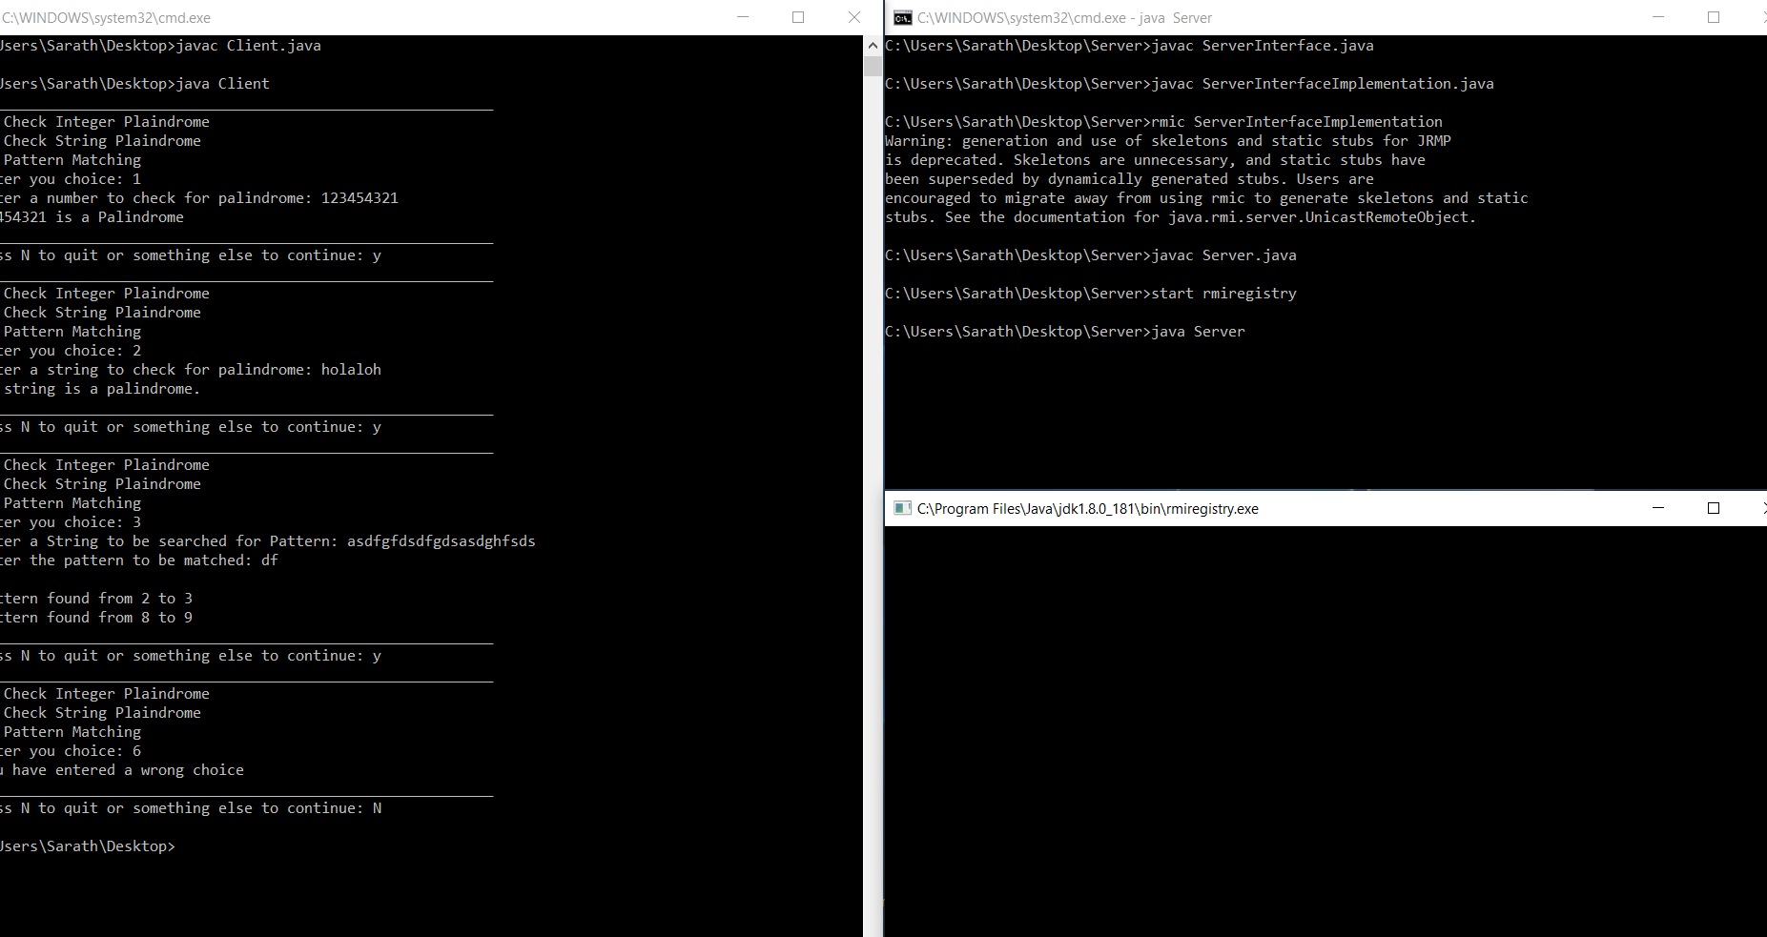

UML Diagram
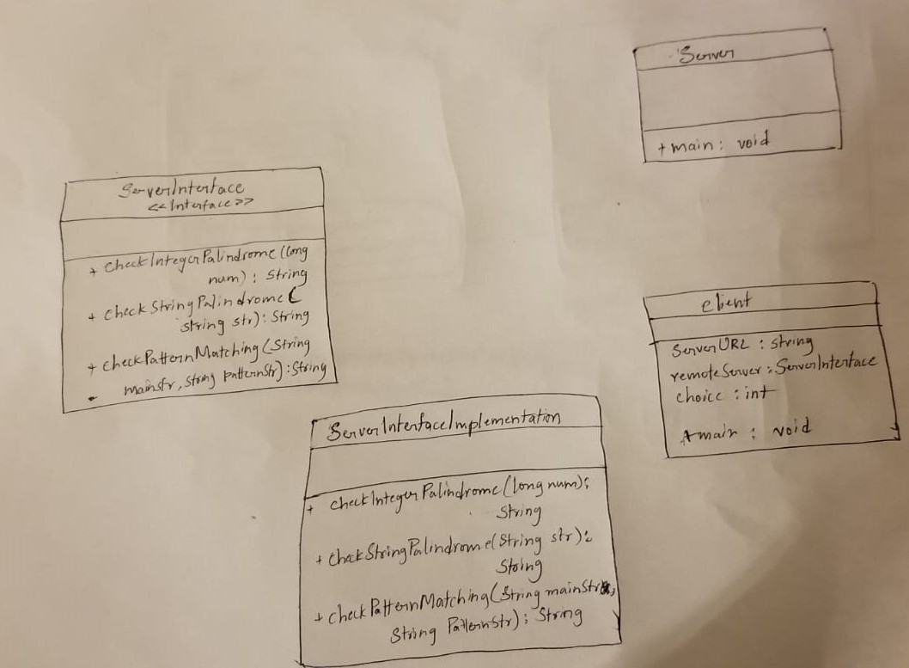

RMI ARCHITRCTURE:
